URL: <http://www.oasishospital.org/>

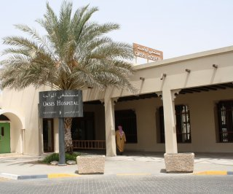 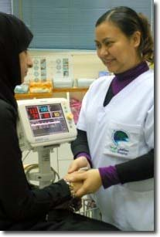

**Our mission**: is to provide an international standard of quality healthcare and services to the communities we serve while representing the compassion and love of Jesus Christ.

**Our vision** is to be the hospital of choice in Al Ain and the neighboring communities.

Our services are guided by the highest standards of the UAE and International hospital accreditation. Oasis has long been well-known as the birthplace of a nation, reflecting the hospital's reputation for first-class maternity and newborn infant care. Our services have consistently grown and expanded, and now provide first-class medical care for the women, children and men of the city of Al Ain and the surrounding region.

**Services:**

Surgery: General surgery, abdominal and laparoscopic surgery, hernia surgery, endoscopic surgery, varicose vein surgery, skin surgery, circumsion.

Radiology

Physiotherapy

Pharmacy

Occupational therapy

Laboratory

Women’s health: gynecology, endocrinology, obstetrics, infertility.

Men’ s health: Andrology, prostate health and infertility.

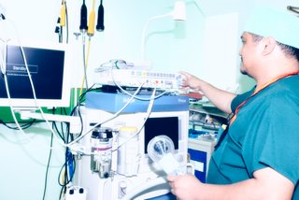 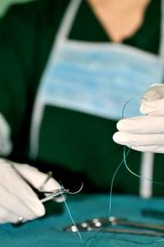

**Doctor’s credentials**

**Doctors in anesthesiology**

Nabil Estemalik

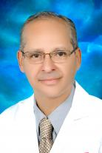

**Head of Department**

Consultant Anesthesiologist

German Fellowship in Anesthesia

Diploma in Anesthesia

Residency Done at Egyptian hospitals

Fellowship Done at German Hospitals

 Khoisnam Dhananjay Singh

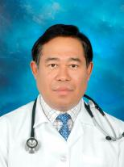

Specialty Anesthesia, and Pain Management

MBBS. DA. MD. Pain Management. Post Graduate Diploma in Hospital Management.

Residency done at Christian Medical College, Ludhiana

Fellowship done at Christian Medical College

 Member of International Association for the Study of Pain; Indian Society of Anesthesiologists; Former Associate Professor of Anesthesia. University of Punjab, Chandigarh and Shivaji Unoversity, Kolhapur, India

Recipient of John Bonica Study Scholarship for Pain 1993. Author: 'Dual Catheter for Labor Epidural" American Society Of Regional Anesthesia 2009. "Is it Necessary to have ACT machine for cardiothoracic Bypass" Indian Association of Cardiothorasic Surgry 1996. "Aerosol Xylocaine for flexible fibre optic bronchoscopy "1987 2nd National update Flexible fiberoptic bronchoscopy. "Semi close circle anesthetic circuit without Co2 absorber" Indian Society of Anesthesiologists, 1994.

**Doctors in gynecology**

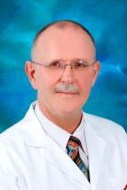

Arnoldus Cornelis Maria Jacobs

**Medical Director**

Consultant OB/GYN

MD

Residency Done at the Academic Hospital, Free University Amsterdam

Sahar Louis Halabia

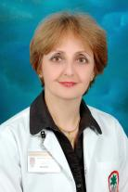

Chair Obstetrics and Gynecology Department  
M.B.Ch.B, CABOG

 Residency Done at The Medical City Teaching Hospital, Baghdad. Al-Elwayiah Maternity Teaching hospital, Baghdad.

 Fellowship Done at The Medical City Teaching Hospital, Baghdad. Al-Elwayiah Maternity Teaching hospital, Baghdad. Ibn Al-Baytar Irish Hospital, Baghdad. Arab Board in Obstetrics and Gynecology. Diploma Gynecologic Endoscopic Surgery & Infertility, Kiel University Germany. Clinical Fellowship of the Royal College of OB/GYN, London.

 Emirates Medical Association, Faculty staff, Senior Lecturer and specialist/consultant in OB/Gyn dept Nahrain Univercity, College of Medicine & the University Hospital. Advisory Board member of Al-Kindy College Medical J. Editorial Board member of Bulletin of the Iraqi Medical Association. International Society of Gynecologic Endoscopists ISGE Member. Medical Discipline & Ethical committee in Baghdad Medical Association.

 Faculty of Medicine and Health Science, United Arab Emirates University, Oasis Hospital Coordinator of clerkship in Obstetrics and Gynecology August 2005. Advanced Life Support Obstetrics Instructor, United Arab Emirates since January 2007. Founder of "The National Congenital Anomalies Registration Center" Iraq. Founder & director "Gynecologic Endoscopy Unit" University hosp Baghdad. Founder & Executive member of the ‘‘Iraqi fertility society IFS''

 Published Works:‘‘Reversal of Female Tubal Sterilization''; Infertility; Poly cystic ovary syndrome"; Female Hyperprolactinemia; Genital Prolapse, Femal Stress Incontinence & Urodynamic Study; ‘‘ Prolapsed single system Ureterocele''; Abdominal Pregnancy; Preeclampsia; Neural tube defect & Congenital anomalies; Stillbirth & low birth weight; Laparoscopy; Family planning; Inrtra uterine contraceptive Device & Infection.

**Doctor in pathology**

Iman Wahib Doss  
  
Clinical Pathology/ Laboratory Medicine

Director of Laboratory Services  
MD, MB BCh, MSc Clinical Pathology

 Residency Done at Ain Shams University, Fever Hospital affiliated with NAMRU in Cairo , Egypt

Fellowship Done at Masters done in Ain Shams University, Cairo, Egypt

Member of the Egyptian Syndicate for Physicians

Published paper in cooperation with Preventive Medicine in Al Ain and Tawam hospital pediatric department regarding the prevelance of Hypothyroidism among neonates

**Doctor in laparoscopic surgery**

Tariq Shadid

Consultant General Surgeon

Laparoscopic Surgery

MD, FDCS

 Residency Done at Groningen University Hospital, the Netherlands

Fellowship Done at Groningen University Hospital, the Netherlands  
Member of Dutch College of Surgeons, Royal Dutch Society of Medicine, Dutch Society for Gastro-Intestinal Surgery, Society of Laparoendoscopic Surgery (SLS)

Honorary Research Fellow at Oxford University, United Kingdom, 1993 - 1994. Noordhuis-Talens award 1999, Groningen University for best teaching qualities

Ahmad Zia

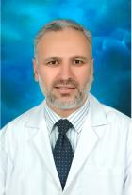

Specialist General Surgeon

MBBS , FCPS(surgery), FRCS(UK)

Residency Done at Khyber Teaching Hospital, Peshawar, Pakistan

Fellowship Done at Royal College of Physicians & Surgeons Glasgow, UK  
and College of Physicians and Surgeons ,Pakistan

**Doctors in pediatric**

Mani Varghese

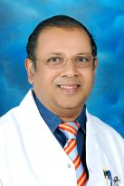

Head Of Pediatrics  
Pediatrics and Neonatology  
MBBS. DCH. MD form CMC, Vellore, India

Residency Done in India

Published Work: Maternal and Neonatal Colonization with Group B Streptococcus and Neonatal Outcome. Indian Pediatrics. Volume 21- May 1984. Pattern of Central Nervous System Anomalies in a population with a high rate of consanguineous marriages. Clinical Genetics 1999; 55:95-102. The profile of major congenital abnormalities in the United Arab Emirates(UAE) population. J. Med. Genet 1995:32:7-13. Obstetric risk factors Affecting Incidence of Low Birth Weight in Live -Born Infants. Biol Neonate 1995;67:160-166. Neonatal Schwartz-Jampel syndrome: a common autosomal recessive syndrome in the United Arab Emirates. J Med Genet 1996;33:203-211. Microlissencephaly Pediatric Neurology 1998; 18:362-365. Neonatal Audit in Countries With Rapidly Developing Economies: Experience from UAE. Folic Acid Awareness and Intake Survey in the United Arab Emirates. Henna causes life threatening hemolysis in glucose -6- phosphate dehydrogenase deficiency. Arch. Dis Child 2001; 85:411-412. Birth Prevalence and Pattern Of Osteochondrodysplasias in an Inbred High Risk Population.

**Iman Isa Marak**

Pediatric Specialist  
MB CH B /Iraq

Arab Board Pediatrics

**Contact us**

Oasis Hospital

Al Ain, United Arab Emirates

PO Box 1016

Tel: +971 3 722 1251

Fax: +971 3 722 2007